10th October 2018

Dear HBA 2018 Superstars

Just a quick personal note to thank you all – students, teachers, librarians, support staff – for the hard work, energy and enthusiasm you put into the Hampshire Book Awards. I know the ceremony was the result of months and months of reading, discussing and voting; it was such a wonderful day and I am thrilled to have won.
I truly loved meeting you all yesterday – it was an honour and privilege to talk to you about Instructions for a Second-hand Heart. Most of all, I loved being a room full of people who love books just as much as me – it felt very much as though I’d found my tribe. And I got some excellent recommendations for my TBR pile as I signed your copies: thank you!
Days like yesterday don’t come along very often; I’ll always treasure and remember it. Thank you for making me feel so very welcome and for choosing my book as your winner.
Lots of bookish love,
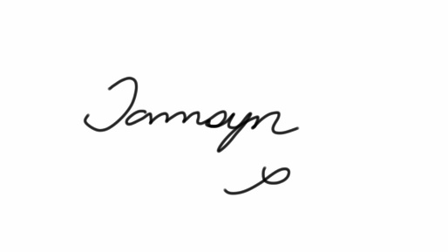

PS I’m counting on you all to keep reading. Don’t let me down!

