**New Learning Zone**

Getting Started

**Guidance for Hampshire Maintained Schools**

SERVICES FOR SCHOOLS

Contents

Accessing the Learning Zone 1

Delegating course approvals 2

Searching the catalogue 6

Finding details of courses you are booked on and for users you manage 8

Booking yourself on a course 10

Booking a course on behalf of another member of staff 12

Approving a booking 13

Withdrawing/cancelling from a course 15

Accessing reports 18

Accessing ‘How to’ guides & other help 20

FAQs 21

Glossary of terms 25

# Accessing the Learning Zone

For Hampshire maintained schools, access to the Learning Zone is via the Hampshire County Council shared services web page

<https://extra.hants.gov.uk/sharedservices>

Click on the **“Learning Zone”** tile to open up the new Learning Zone

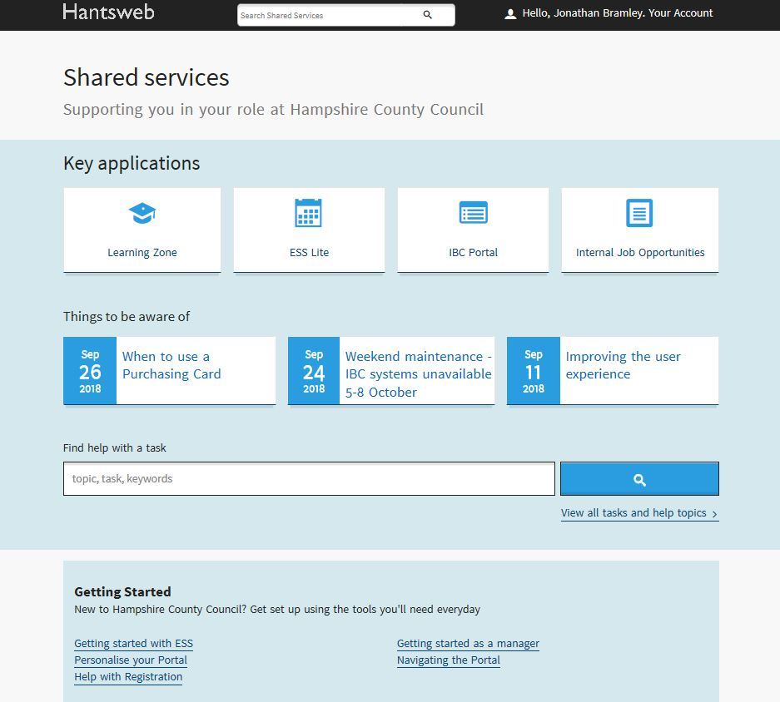

# Delegating course approvals & acting as a delegated manager

**Topic**

Delegate the course approvals process from a Line Manager (e.g. Headteacher) to someone who can act on their behalf (e.g. School Manager/Administrator)

**Description**

How to assign delegate authority to others so they can action course approvals for all employees reporting to you, permanently or temporarily,

**Process**

Access Hantsweb and click on **Learning Zone** tile.

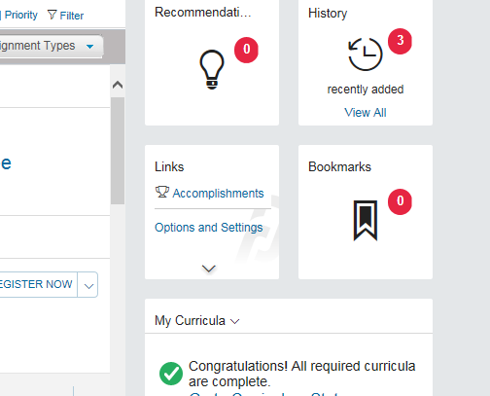On the **My Learning** page, navigate to the **Links** section which is located underneath the ‘Learning Assignments’ box. Click on **Options and Settings.** The **Options & Settings** page will display.

Click the **Add** button in the **Delegates** area and the **Add Delegate** page will open.

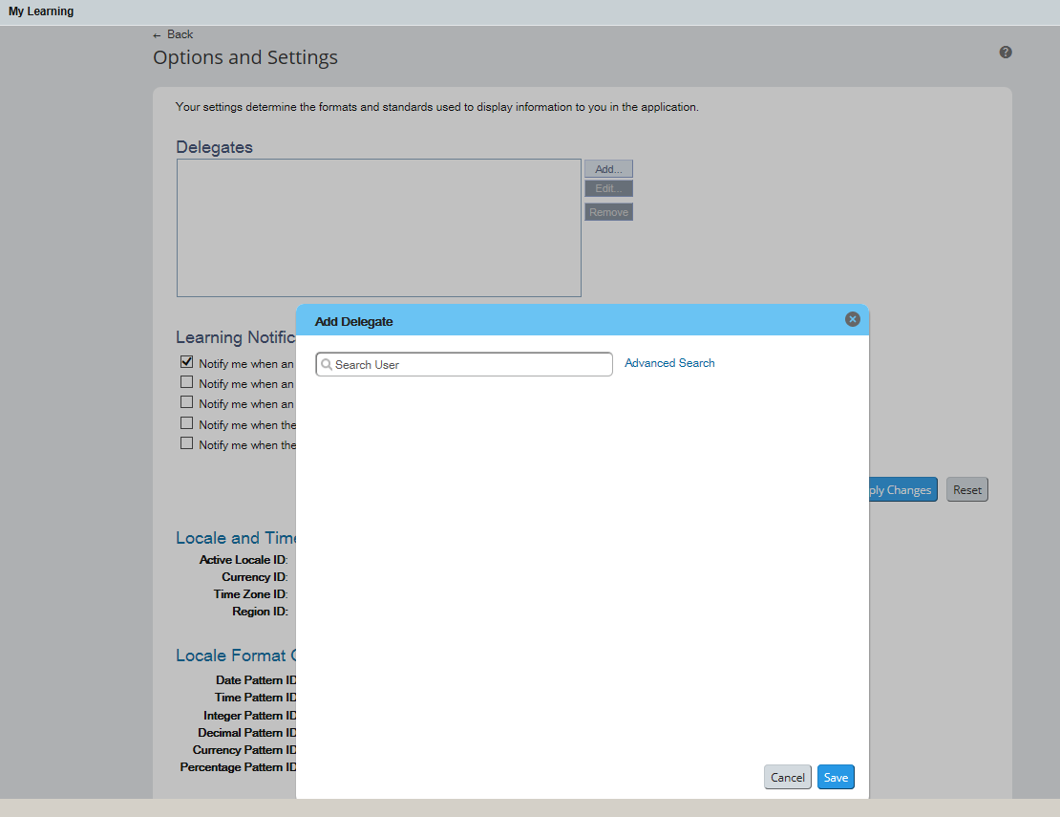Use the search box to find and select the person you want to delegate for you. You can also use the **Advanced Search** option to find and select a delegate based on predefined criteria.

Once a delegate has been identified, select **Predefined Permissions** option for the user.

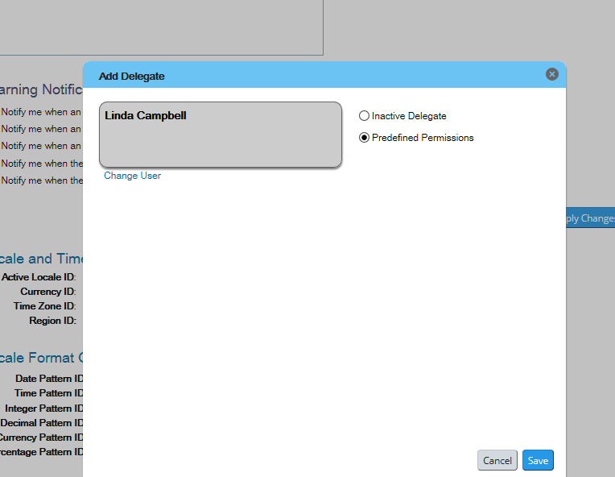

Click the **Save** button. The Delegate is now selected and permissions are assigned.

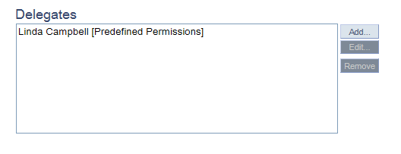Your delegate will be shown. You can remove them by clicking REMOVE.

Once selected as a delegate, the individual will receive the following email as confirmation:

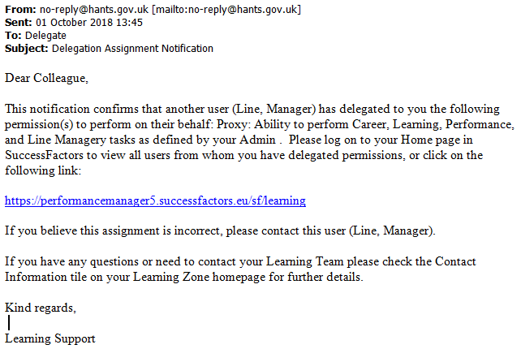

In order to act as the delegated manager the individual will need to follow the steps below.

**Step 1:** From the learning home page, go to links, then from Delegator list select the manager

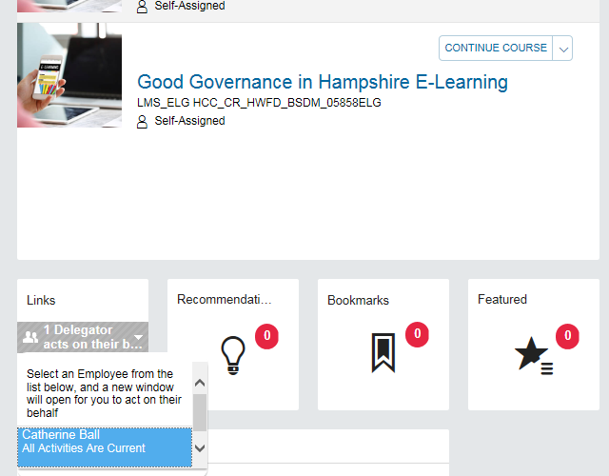

**Step 2:** The delegate view will open in a new window (you may have to allow pop up and then repeat step 1 above).

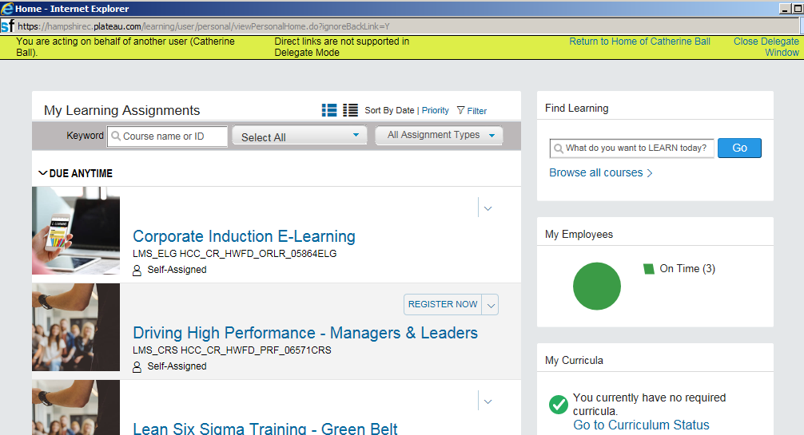

**Step 3:** Perform required tasks on behalf of the manager. Please note, the user’s own My Learning Page becomes inactive whilst the delegate window is open.

**Step 4:** Close the delegate window when tasks are complete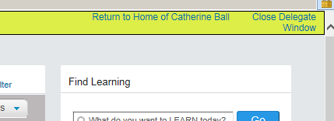

# Searching the catalogue

**Topic**

Browse/search the LMS catalogue

**Description**

Searching for courses to find a scheduled offering, (instances of the courses that are available for booking) to meet your development needs.

**Process**

Access Hantsweb and click on the **Learning Zone** tile.

On the **My Learning** page, navigate to the **Find Learning** section on the right of the page.

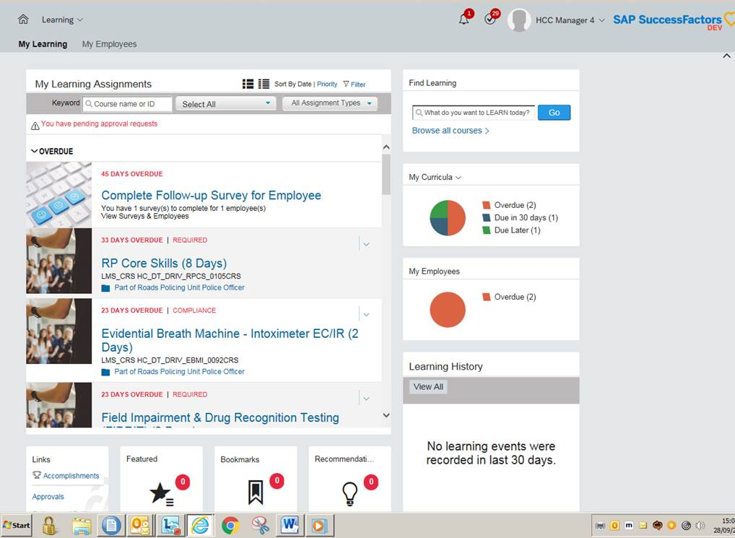

In the **Find Learning** area, you can find learning in two ways:

* If you start typing in a course name, the LMS will suggest titles based on this which you can click on to select. Then click **Go** to be taken to a results page with all relevant items, or
* You can also click on **Browse all courses**, taking you to the **Catalogue** page, where you can click on the magnifying glass in the **Search** field to see all the courses you’ve been given access to

Once you are on the **Catalogue** page, you can **Browse by Topic**, which allows you to look at available learning by subject area.

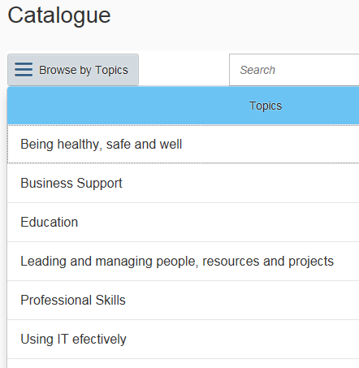

Once results are listed, you can filter these further, by **category** and **delivery method** using the drop-down options under the **Refine By** heading on the left.

Once you have found the required learning, you can enrol onto the learning.

# Finding details of courses you are booked on and for users you manage

**Topic**

View/access my learning history

**Description**

Helping track and manage learning, providing a view of completed courses and printing certificates

**Process**

Access Hantsweb and click on the **Learning Zone** tile.

Bookings and / or Required learning is displayed in **My Learning Assignments** on the landing page.

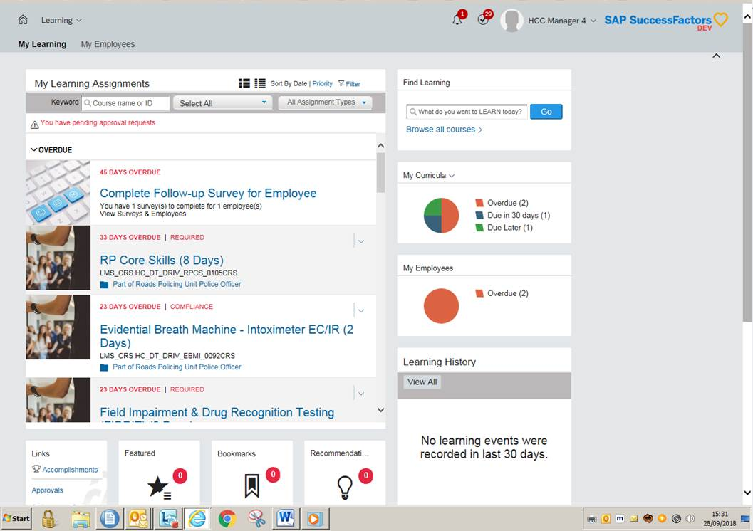

On the **My Learning** page, navigate to the **History** section at the right hand side of the page. The **History** tile provides you with a list of recently completed work. This will be blank if no learning events were recorded in the last 30 days.

Select a title to view the details of the completed course.

Alternatively, clicking the **View All** link takes you to your **Completed Work** page.

**Completed Work** lists courses by **Completion Date, Title** and **Status.**

Use the **Show Completions** drop-downto filter completed work by date. You can filter **After** a date**, Before** a date**,** or **Between** two dates**.**

Use **Title** to search and filter course work by keywords in the title.

Select **Status** to filter completed work by the listed status e.g. **All, Course Attended, eLearning Complete** etc.

To review the details for the completed course, hover over the course title. Select **View Details** to view the complete registration information for the course including completed course hours. Select **Print Certificate** to print a certificate of completion for events.

**Managers who wish to view the learning of employees reporting to them**

Select **My Employees** by either clicking the ‘My Employees’ tile or the ‘My Employees’ tab alongside the ‘My Learning’ tab (note that if you are accessing the system as a delegated manager, you will not see the ‘My Employees’ tab, so will need to use the tile). A list of employees reporting to you will be displayed on the left and you can select which employee to view by clicking their name.

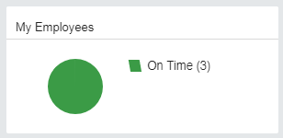

# Booking yourself on a course

**Topic**

Register onto an instructor-led/virtual learning course

**Description**

Enrolling either by self-service or being enrolled by a manager who line manages them.

**Process**

After browsing the catalogue) and finding a course you are interested in enrolling onto you can:

* Click on the course title or **More,** to view course details
* Click on **Assign to Me**, which puts the Learning Item in your learning plan, but doesn’t actually book you onto the course
* Click on **See Offerings** to review scheduled offerings (dates) available, and if you want to book onto a specific scheduled offering, click on **Register Now** button

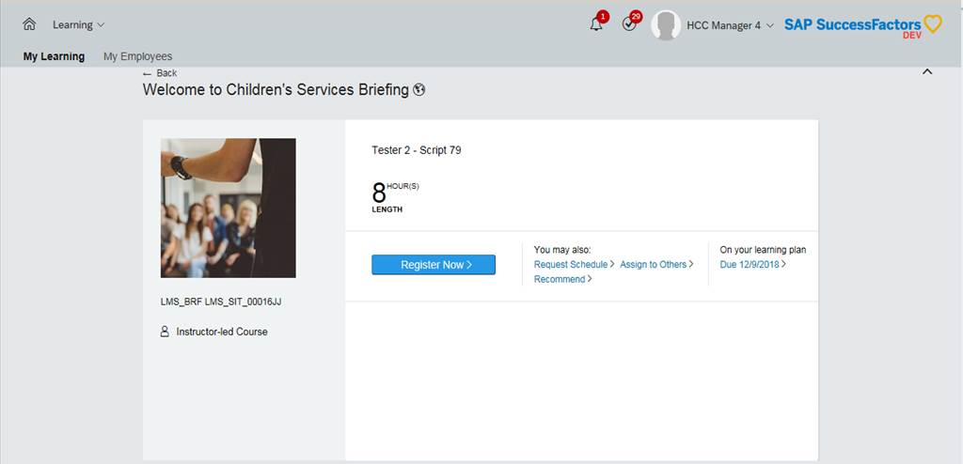

Check the information provided including any pricing, and add any information about accessibility or dietary needs, and then click **Confirm**. If a booking needs your Line Manager’s approval then after you have clicked **Register Now** and **Confirm** buttons, you will see a message asking if you want to proceed. Click **Yes.**

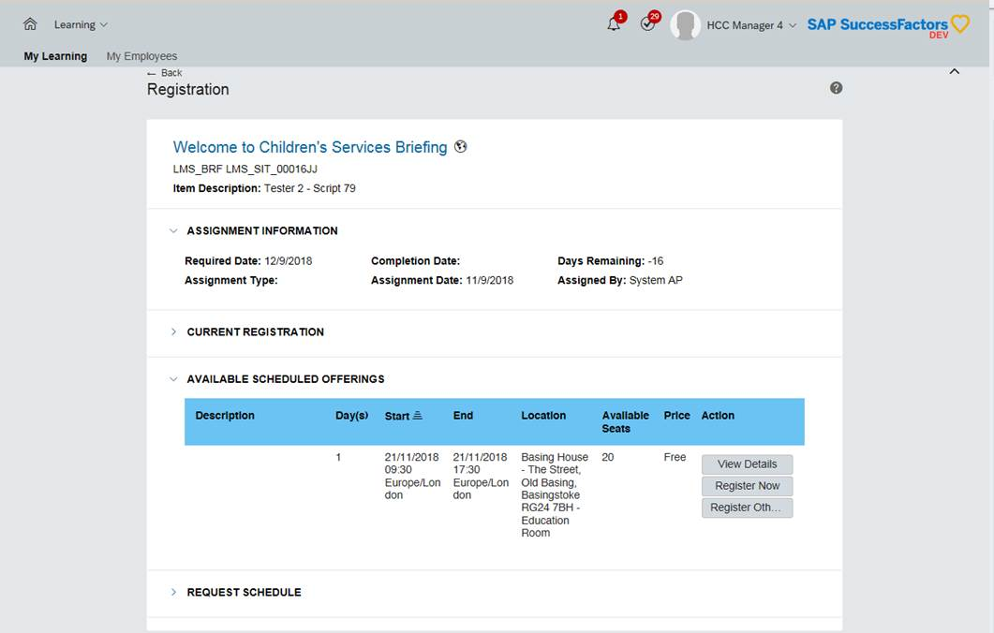

Your place will not be confirmed until your Line Manager approves the request. The system will send you a pending notification of your request, and your manager a registration notification of your request which they will have to action.

After your manager has reached a decision, you will receive either a registration approval notification or a denial notification depending on the decision taken. If your request is approved, your **My** **Learning Assignments** section is updated.

# Booking a course on behalf of another member of staff

**Topic**

Managers (including delegated managers) who wish to book learning for employees reporting to them

**Description**

Enrolling employees onto courses/Adding learning items in the catalogue to your team member’s learning plan

**Process**

Access Hantsweb and click on **Learning Zone** tile.

If you are acting as a delegated manager, follow the instructions on page 5 and 6 of this workbook and ensure you have the delegate window open before attempting to complete any actions on behalf of the manager.

Click on the **My Employees** tab at the top left of the **Learning** page (or the ‘My Employees’ tab if you are acting as a delegate).

You then have three ways of assigning learning:

1. Select the employee you want to find a course for from the list on the left, then click on the three dots next their name, select **Assign Learning** from the menu displayed and the **Assign Learning** page will open. Use the **Add** button next to **Item, Programs and Curricula** to find and select courses and click **Continue** and then **Assign Learning** to confirm your choices (Help finding and selecting a relevant course can be found here: Browse/search the LMS catalogue), or
2. Go to the **Find Learning** area on the right hand side of the **Learning** page, find a course by using the search box or clicking **Browse all** courses, to navigate to the **Catalogue.** Courses are displayed in tiles. Click **Assign to Others** located at the bottom left of each tile, or
3. Go to the **Line Manager Links** area on the right of the page, click on **Assign/Remove Learning** and then select **Assign Learning**. Use the **Add** button next to **Item, Programs and Curricula** to find and select courses and the **Add** button next to **Employees** to select the relevant team members. Then click **Continue**, and finally confirm your choices by clicking **Assign Learning**

The system will automatically send registration notifications to you and the Learner.

Note: You can also use the last method to remove learning.

# Approving a booking

**Topic**

Approve a request for a course

**Description**

Some training sessions require manager approval. Managers are notified of the approval requests. Requests are marked as pending until approved, Note: places continue to be offered to others until this step is complete

**Process**

Access Hantsweb and click on the **Learning Zone** tile.

Click on **My Employees** link at the top left of the **Learning** page.

From there, navigate to the **Line Manager Links** link on the right hand side of the page.

Click **Approvals** to bring up a list of all pending employee training requests.

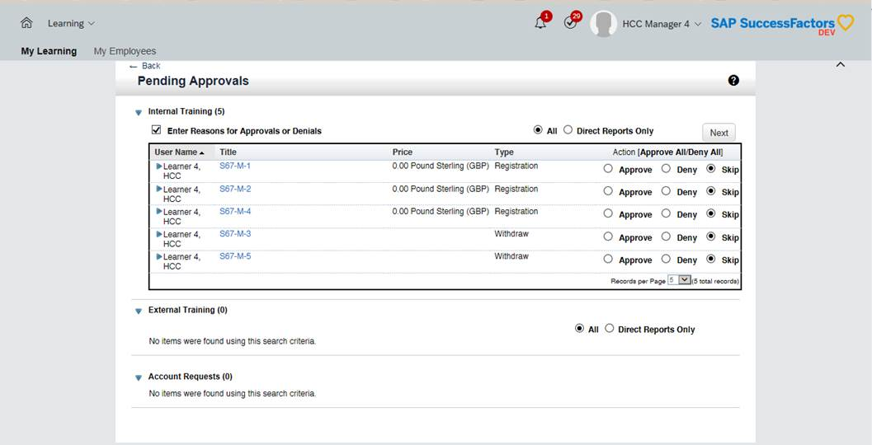

Make sure the **Enter Reasons for Approvals or Denials** box is checked so that you can add comments to explain your decision.

Click on the **course title** to review the course details to help you make your approval or denial decision. Once you have finished, click the **back** button to go back to the pending approvals list.

Once you have reached a decision, choose the appropriate button to:

* **Approve** the training request
* **Deny** the training request
* **Skip** approving or denying this request at this time (only works if you have more than 1 approval request to action)

Click **Next.**

Explain why you have approved or denied the training request in the text box provided. Click **Next** once complete**.**

Click **Confirm** to complete the approval workflow.

Click **Start Over** to return to the Pending Approval page.

# Withdrawing/cancelling from a course

**Topic**

Cancel my enrolment on a scheduled offering

**Description**

Requesting withdrawal from a course

**Process**

**Withdrawals before the cancellation period – no Manager approval**

Access Hantsweb and click on the **Learning Zone** tile.

Navigate to the **My Learning Assignments** page. Find the relevant learning item title in your learning assignments. Click on the arrow next to the title to expand the **Options** menu. Click **Withdraw**.

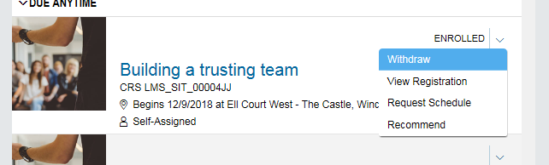

A **Warning Message** will appear asking if you want to withdraw from the session**.** Click **Yes.**

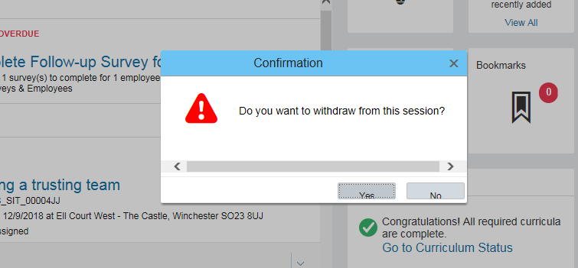

A **Remove** window will open. Choose **Yes** or **No** depending on whether you want to update your learning plan.

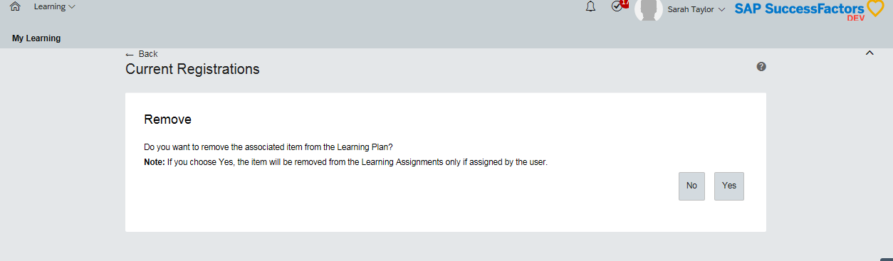

Note: You may want to withdraw from a specific date but not remove the course from your learning plan if you still want to do the course in future. After withdrawal, the scheduled offering with a no enrolment status in the learning plan will act as a reminder for you to enrol onto future offerings.

Select a cancellation reason from the drop down list. Click **Submit.**

Note: You must select an option before proceeding with the withdrawal. If an option you require is not available, contact your learning team for assistance.

If the course is a charged course, you will be informed of how much will be refunded to your cost centre by withdrawing. Click **Yes.**

If Manager approval is not required to withdraw, the withdrawal is now complete and your **My** **Learning Assignments** section is updated. It will either display no enrolment status for the scheduled offering if item was not removed from the learning plan when the withdrawal took place, or the scheduled offering will no longer show as assigned if the item was removed during the withdrawal process.

**Withdrawals before the cancellation period – Manager approval required**

If Manager approval is in place for the scheduled offering, then after selecting the cancellation reason and clicking **Submit**, a message will appear indicating that the course requires approval for withdrawal. The page also displays the approver(s) who will be contacted to approve the request. Click **Submit**.

The system will send you a pending notification of your withdrawal request, and your Manager an approval notification of your withdrawal request which they will have to action. After your Manager has reached a decision, you will receive either a withdrawal approval notification or a denial notification depending on the decision made.

If your withdrawal request is approved, your **My** **Learning Assignments** section is updated. If your withdrawal request is denied, you will remain enrolled on the course.

**Withdrawals within the cancellation period**

Access Hantsweb and click on the **Learning Zone** tile.

Navigate to the **My Learning Assignments** page. Find the relevant learning item title in your learning assignments. Click on the arrow next to the title to expand the **Options** menu. Click **Withdraw**.

An error message will be shown to inform you that you cannot withdraw from the course as the withdrawal cut-off date has passed.

You will need to contact the HTLC Events Team to make an off system withdrawal request.

# Accessing reports

**Topic**

Run a report

**Description**

Generating reports about learning undertaken by employees that you line manage (current and history)

**Process**

Access Hantsweb and click on the **Learning Zone** tile.

On the **My Learning** page, navigate to the **Links** section at the right hand side of the page. Click on **Reports.**

View the list of available reports on **Reports** screen. Click the expand icon to see additional reports in each report group.

Click on a report name to select a report and display the run report screen.

Each report page may allow you to customize the report layout by entering **Report Title, Report Header, Report Footer** etc.

Use the drop down menus and criteria fields to determine options for **Report Destination, Report Format, Report Type, Include, Print Comments, Sort By, List By** etc. as appropriate.

Enter the **Completed Date From** and **Completed Date To** dates if applicable.

Supervisors may choose to run a report for themselves only, their direct subordinates, all subordinates, or all including themselves.

Once all fields are defined, click **Run Report**.

The report will begin processing – the status will read **Waiting in Queue**, then **Generating**, then **Succeeded** when complete.

Once completed, you will see a message to say that your report is automatically downloading, and a pop up box will appear at the bottom of the screen asking what you want to do with the report:

* **Save** – to open the report
* **Save as** – to save the report to a location of your choice
* **Cancel** - to cancel

**Examples of learning reports**

|  |  |
| --- | --- |
| Certificate of Completion Report | * This report enables you to create a report of printable certificates of completion for Learners * Use the query screen to search for a Learner or Item requiring certificates. Use the Run Report for Completed learning events * This report prints the certificates of completion for Learners by Item |
| User Item Report | * This report displays information about a Learner’s completion status for learning during a specified time period * Use the filters to select the Learner, Item, completion status, and date range to run the report against |
| Learning History Report | * This report displays information about Items that Learners have completed * Use the filters to select the Learner and date range for which you would like the report to return results * This report returns the Learning History (completed Items) for the Learner |
| Learning Needs Report | * This report displays information about the Items that have been assigned to the Learner that need to be completed * Use the filters to select the Learner, Item and Required Date range for which you would like the report to return results |

# Accessing ‘How to’ guides & other help

**Topic**

Contact us

**Process**

**Access problems**

If you are unable to access the **Learning Zone**, please contact the **HCC** **IT Help Desk** by calling **01962 847000**.

If you **are** able to access the **Learning Zone**, the following may be able to help you with your enquiry:

* **Help pages** – a full set of How to guides is available towards the bottom of the shared services web page, which is where the Learning Zone tile is situated - <https://extra.hants.gov.uk/sharedservices>
* **Information tile:** This tile is situated on the bottom left hand side of the **My Learning** page and will contain information about your learning co-ordinator and how to contact them. The tile also includes information regarding cancellation policies.
* **Email notifications:** Any emails you have received from the **Learning Zone** will have information to direct you to the **Information** tile on your **My Learning** homepage.
* **Course details:** By going to your **My Learning Assignments** section on your **My Learning** page, you can click on an item title, which will provide you with contact information for the course.

**Talk to us**

If you need to speak to one of your **learning co-ordinators,** you should use the contact details below:

**Email:** [htlc.course@hants.gov.uk](mailto:htlc.course@hants.gov.uk)

**Telephone number:** 01962 718600

# FAQs

**What info is required to log in?**

You won’t need to log into the LMS itself. Access is via ESS. To access this you will require your Personnel Number, Password and Memorable Word (you will need to register if you haven’t previously)

If staff struggle to access ESS IT service desk will be able to help with this

**What about people with two Personnel Numbers/ multiple employment?**

Such people will have two learner records. This is because courses may e assigned by role and also an individual may have management responsibility in one role so they need to have separate records for each role.

**Can we add our own training?**

This is a possible future development.

**Can we record learning that has taken place outside of the system?**

Yes via a Recognition of Prior Learning process. HTLC booking team can add a record of training undertaken outside of the LMS.

**Can a manager set a substitute?**

Yes this is referred to as delegating. Guidance of how to do this, can be found, together with screen shots within the slide pack.

**How will this work for Federation of schools?**

The HT will need to ensure the substitutes are set that have oversight of each school within the federation.

**Can the named Online Booker on CAS be transferred as a substitute in the LMS?**

No. This has to be set up by the Manager.

**If a manager books a course on behalf of a member of staff will they also receive the joining instructions?**

Not by default, however it is possible to change settings in the system to make this happen. Concerns around this area have therefore been passed on to HTLC to consider.

**Will notification emails be sent out at 3am?**

Most notifications will be sent as soon as actions are taken but there is a possibility that emails will be generated overnight as large IT jobs tend to run over night to spread the load and prevent computer crashes.

**What about courses done on paper or not through the Learning Zone?**

Depending on the nature of the training a record of this learning may be able to be added by an administrator in HTLC.

**Will evaluations stay on My Learning until completed?**

In general, yes.  Some evaluations learners will be able to remove if they are optional.  Others must be completed before the learning history is updated to show the learning, e.g. HLTA courses.

**Will staff who’ve changed school still be able to access records from the original school?**

Yes, so long as they stay within a Hampshire maintained school. If they were set as the substitute manager – they should be removed by the Headteacher.

**Can we still use un-named delegates**?

No. The LMS requires a named learner for course enrolment.  Training providers will be contacting schools to get names where un-named delegates have been used in existing bookings.

**Will eLearning work?  Sometimes it doesn’t currently!**

Yes – it is being embedded in the LMS and so it is easy to access and will track progress and completion.  Some eLearning is being recreated as errors had been identified.

**Can ESS have more than one email input? Some might prefer 2 email addresses – a personal one to access payslips etc. – and a work one for training etc.**

Whilst a number of email addresses can be recorded on ESS lite, it is the email address recorded as the ‘correspondence email’ field that is used by HCC for both payslips and training notifications. These cannot be separated.

Our recommendation is for schools to ask all staff to ensure that their work email address is recorded as correspondence email address on ESS Lite.

**Are budget reports available?**

Yes this will be included in the standard reports.

**Is there a Report showing learning completions?**

The report “Learning History (CSV) (the detailed version on the options screen) shows which courses (including eLearning) the manager and employees have completed, including if they didn’t attend. The Learning Plan (CSV)” shows which courses are on Learning Plans (ie have not been started or completed yet) – it also shows the number of days until (or since) it expires.

**Can management responsibilities be split i.e. approval and booking?**

The head teacher can delegate management responsibilities to a number of other staff. All these individuals then have the same management rights with the ability to approve requests and make bookings. Who performs what tasks then needs to be decided as an off-system process.

**Will there be step by step instructions for all staff?**

Help guides will be available from the shared services page (see Learning Zone Guidance tile)

**Who would approve training for the head as they would have no line manager?**

No-one via the approvals process in the LMS.  The approval process relies on the line manager field being populated in the Employee Profile.  HTs do not have a line manager in SAP therefore no approval will be sent.  When a HT registers themselves onto a course, they are enrolled straight away.

This is not the same for manager substitutes as they have the HT as their line manager on SAP.  In this case, the manager substitute could authorise their own registration, so there needs to be a local process for authorising these registrations.

**Will heads still get all the notification emails even after they have delegated?**

Yes the head and anyone who they delegate to be a manager will be getting all notifications. We recommend that rules are set up in email inboxes to deal with notifications as required. Guidance on this is also attached.

**Is there a report for who has and hasn’t completed particular learning such as PREVENT e-learning or Fire Safety?**

Yes there is a standard report which will allows you to do this.

# Glossary of terms

**Learning Item**

An individual piece of learning with set learning objectives.

**Scheduled Offering**

An instance of a Learning Item that happens on a specific date (or dates), in a location.

**Catalogue**

A catalogue is where users view/search the learning that is available to the.

**Curricula**

A collection of learning items grouped together

**Program**

A collection of learning designed to be both flexible and structured (learning items or external items).